Microsoft Fabric – Sales & Returns Analytics Pipeline

1. Project Overview
This project demonstrates a complete end-to-end data engineering and analytics workflow built using Microsoft Fabric.
The objective is to ingest Sales and Returns data from a GitHub repository, process it through the Fabric Lakehouse, design a dimensional model, and deliver analytical insights through a Power BI report.
The project highlights:
- Metadata-driven ingestion
- Parameterized pipelines
- Automated validations
- Delta Lake–based transformations
- Dimensional modeling
- Semantic model creation
- KPI-driven Power BI reporting
This serves as a portfolio-ready project showcasing modern skills in Fabric, Lakehouse, PySpark, and BI analytics.

2. Dataset Description
The solution uses two primary datasets sourced from GitHub:

1. Sales Dataset
Contains transactional information such as:
- OrderID
- CustomerID
- ProductID
- OrderDate
- Quantity
- Unit Price
- Sales Amount
- Shift Mode
- Priority Category

2. Returns Dataset
Captures return-related metrics such as:
- Returned OrderID
- Return Quantity
- Return Reason
- Return Date
These datasets represent typical elements found in a retail or online commerce system and are used to derive KPIs like sales performance, customer behavior, and return trends.

3. Lakehouse Architecture
The project uses Fabric Lakehouse as the central storage and processing layer.

Architecture Highlights:
- Raw files ingested from GitHub into the Lakehouse
- Data stored as Delta tables for ACID transactions
- Standardized folder structure
- PySpark transformations for cleaning and harmonizing data
- Output curated tables that feed the semantic model

Why Lakehouse?
- Combines data lake flexibility with warehouse reliability
- Provides one storage layer for analytics, ML, and reporting
- Fully compatible with Delta Lake features (schema enforcement, MERGE, versioning)

. Metadata-Driven Ingestion Pipeline (Fabric Pipelines)
The ingestion pipeline is designed using parameterized and dynamic logic, enabling the same pipeline to process multiple datasets without rewriting code.

Key Features:
- Dynamic dataset mapping
- JSON-driven configuration
- Schema validation
- Column alignment
- Automated ingestion into the Lakehouse
- Reusability across new datasets with minimal changes

Pipeline Steps:
- Fetch file metadata and configuration (file path, delimiter, load type)
- Read source file from GitHub into Fabric
- Apply ingestion rules (dtype adjustments, null handling)
- Write output into Lakehouse tables in Delta format
This approach eliminates hardcoding and ensures long-term scalability.

Pipeline Activity:
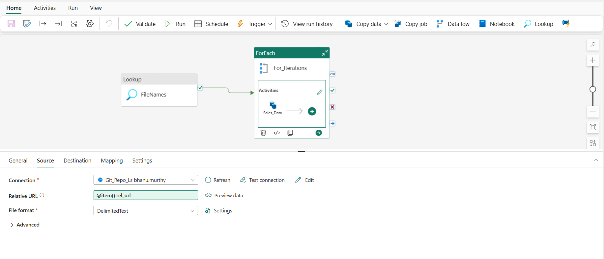

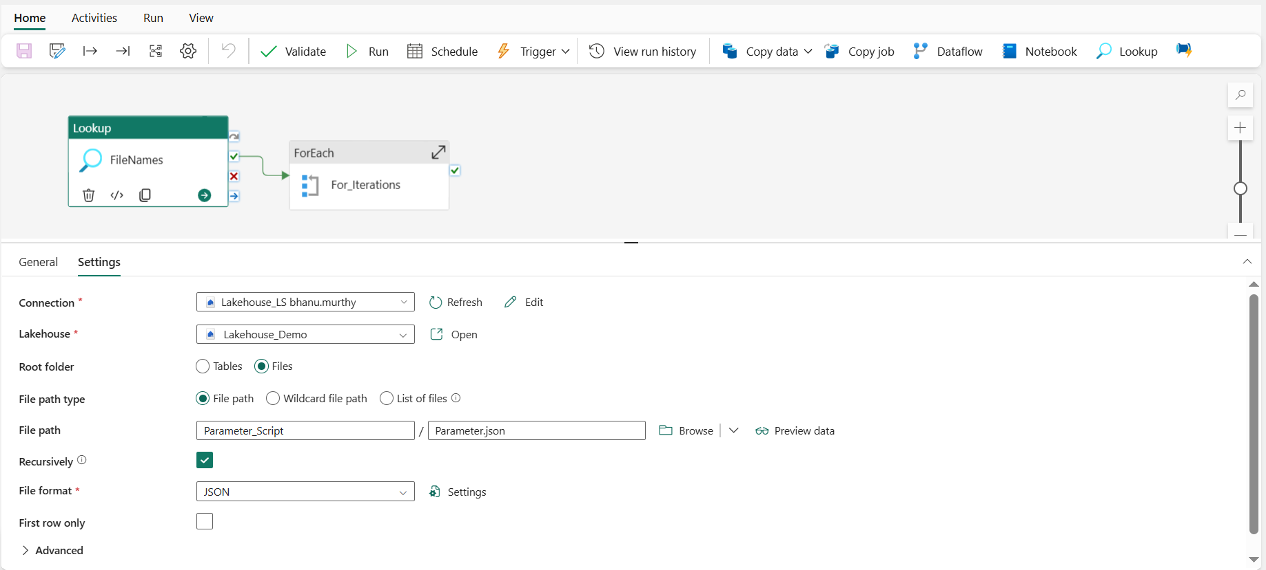
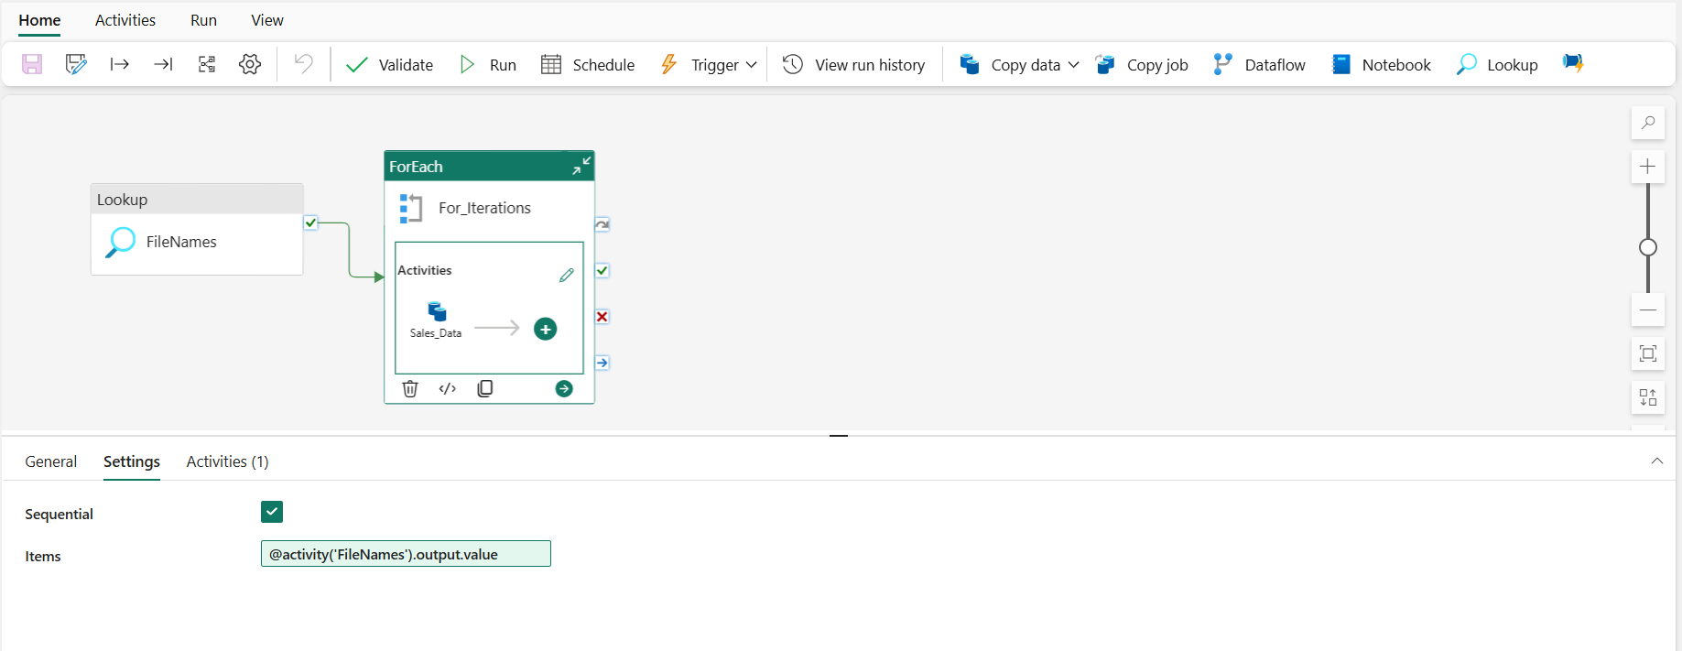

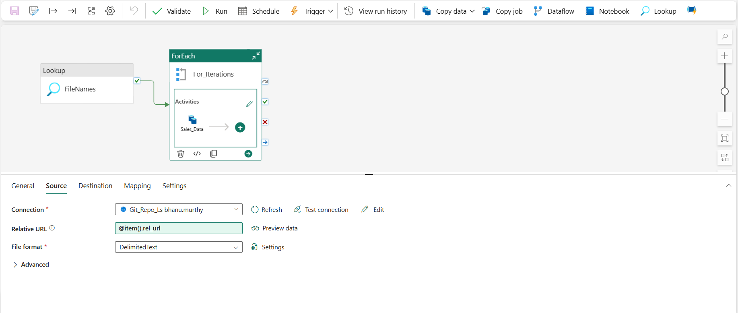

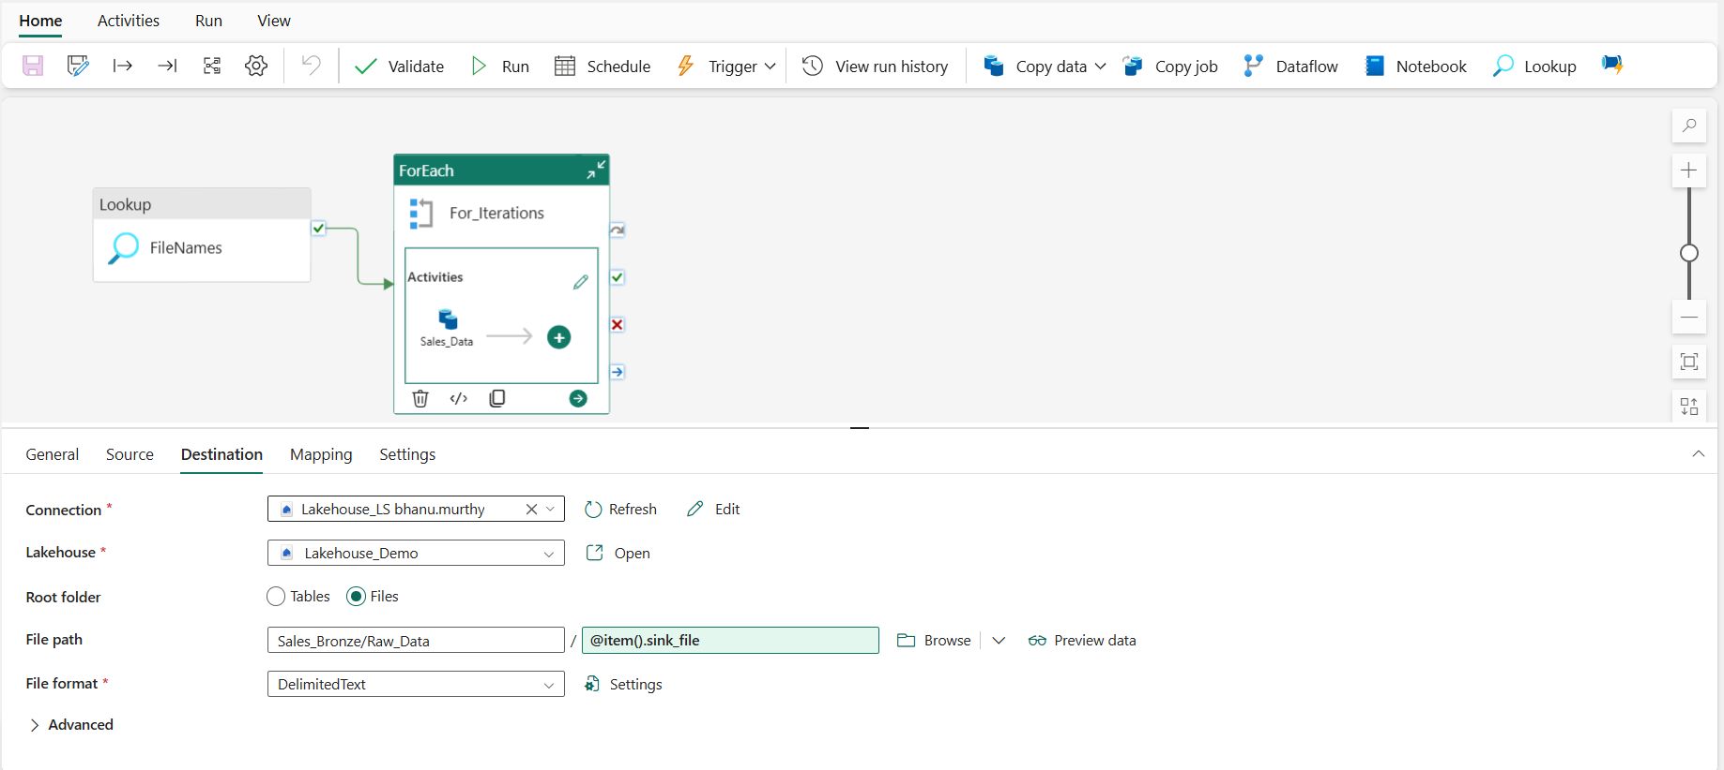

5. Data Transformation Using PySpark
PySpark is used inside Fabric notebooks to prepare the data for analytics.

Transformation Logic Includes:
- Schema enforcement
- Deduplication
- Data standardization
- Date and time conversions
- Referential integrity checks
- Normalization of metrics
- Business rule application
The cleaned output tables serve as the foundation for dimensional modeling.

6. Dimensional Model (Star Schema)
A well-structured dimensional model is designed to support analytical queries efficiently.

Dimensions:
- DimCustomer – demographics and customer attributes
- DimProduct – product attributes and categories
- DimOrder – order-level descriptive details
- DimShiftMode – operational shift categories
- DimOrderPriority – priority groupings such as High, Medium, Low

Fact Table:
- FactSales – combines Sales and Returns measures
  - Sales Quantity
  - Sales Amount
  - Return Quantity
  - Return Percentage
  - Derived KPIs
The dimensional model improves query performance and provides a clean structure for BI reporting.

7. Semantic Model (Fabric)
The semantic model is built on top of the curated Lakehouse tables for easy consumption by Power BI.

Key Components:
- Measures for Total Sales, Total Orders, Return %, and product performance
- Relationships between dimensions and facts
- Data types and formatting
- Column hiding to present a clean reporting surface
- CALCULATE-based DAX expressions for advanced KPIs
This model ensures fast, interactive reporting with minimized Power BI-side transformations.

Semantic Model:
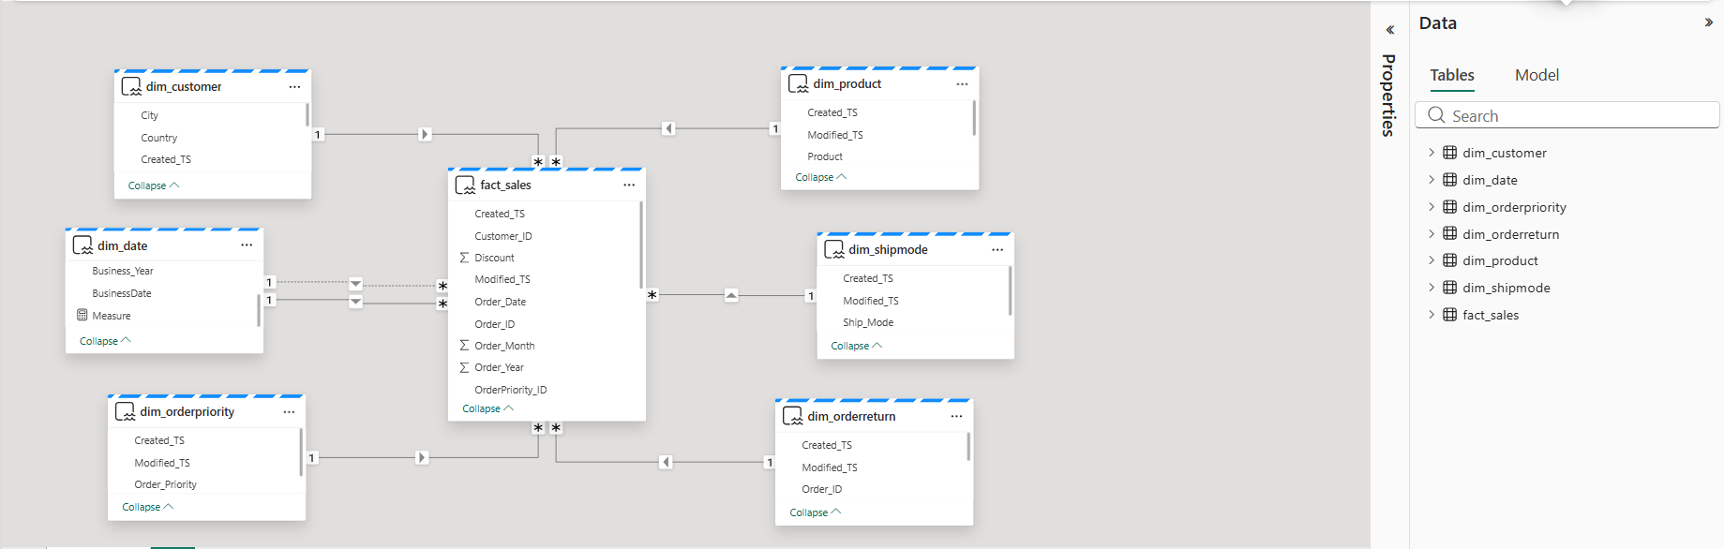

8. Power BI Report Overview
The final Power BI report highlights end-to-end analytics capabilities with:

Primary KPIs:
- Total Sales
- Total Orders
- Return Percentage
- Product Performance Trends

Visuals Include:
- Sales by Customer
- Sales vs Returns trend
- Top-selling products
- Order distribution by priority
- Sales by shift mode
- Return behavior analysis
The report demonstrates the complete journey from raw data ingestion to business insights.

